RASTER AND VECTOR IMAGES

Student Name. Asma Saleem
Roll Number. 2024-CET-07
Course / Subject. IPT
TASK: 01
Submitted to. Engr Sidra Rafiq

Exercise 1: Identify Image Type
Five image examples are presented below. Each image is classified as raster or vector by checking how it is constructed. Raster images consist of pixels, while vector images consist of paths and geometric shapes.

Image 1 – Landscape

Raster (PNG). It is made of pixels and contains continuous colour changes, shadows and fine details. Enlarging it too much can make it look blurry.

Image 2 – Flower illustration

Raster (PNG). The petals, colours and soft edges are stored as pixels. The image is not made of editable mathematical paths.

Image 3 – Pixel-style icon

Raster (PNG). Its coloured blocks are individual pixels. It is suitable as a small bitmap graphic.

Image 4 – Brand logo
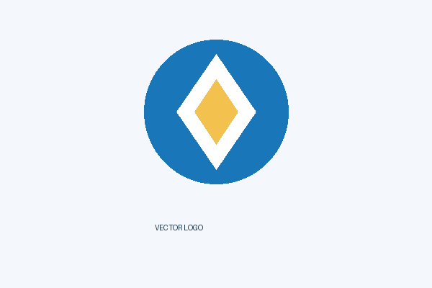
Vector (SVG). The logo is built from circles, paths and text. It can be enlarged without becoming pixelated.

Image 5 – Geometric illustration

Vector (SVG). It uses rectangles, circles and a triangle. Each shape can be resized and edited separately.
Result: Images 1, 2 and 3 are raster images. Images 4 and 5 are vector images.

Exercise 2: Convert Raster Image into Vector
A simple raster symbol was selected and traced into vector paths. The raster source is shown first, followed by the vector result preview. The SVG file is also included with the assignment.

Step 1: Original Raster Image

The source image is a PNG bitmap. Its circle, diamond and centre are represented by pixels.

Step 2: Vector Tracing Result
The same design was recreated as SVG paths and shapes. The SVG version is scalable and its shapes can be edited separately.

Procedure
- Open the PNG image in a vector graphics program such as Inkscape or Adobe Illustrator.
- Select the image and choose the Trace Bitmap or Image Trace option.
- Choose a suitable tracing mode and apply the trace.
- Inspect the created paths and remove the original bitmap if the traced result is correct.
- Save the result in SVG format.
Result: The simple symbol was converted into an SVG-style vector drawing. Tracing works best with simple shapes and clear edges. Photographs are harder to trace accurately because they contain many colours and details.

Exercise 3: Format Testing – JPEG and PNG
The exact same landscape image was exported at the same dimensions in JPEG and PNG formats. The two saved files were then compared.

JPEG Version

File name: same_image.jpg | Dimensions: 1200 × 667 pixels | File size: 21.6 KB

PNG Version

File name: same_image.png | Dimensions: 1200 × 667 pixels | File size: 42.7 KB
Comparison | JPEG | PNG
Compression | Lossy compression | Lossless compression
File size | 21.6 KB | 42.7 KB
Quality | Some image data is removed | Pixel data is preserved
Best use | Photographs and smaller web files | Graphics, screenshots and transparency

